GMS Application Access for New Users

All application users will need to have an OH|ID account through the DODD Portal in order to request access to any of DODD’s Applications.

IMPORTANT INFORMATION!!
- The first account user granted access in GMS will be designated as the account ADMIN. This means that they will have permissions for adding or removing users associated with the account as well as have the ability to designate other ADMINS.
- Each organization should select who their ADMIN should be and have that individual establish a GMS account before other users begin requesting access.

Note: If you already have an OH|ID username, please skip to page 3 “Requesting Access to DODD Applications”. For any registration or login issues, please contact grants.invoices@dodd.ohio.gov.

Creating an OH|ID account through the DODD Portal

- Navigate to the DODD homepage (http://dodd.ohio.gov) and click the “Login” button (highlighted below) in the right hand corner.

- On the page below, click the “Create New Account” button.
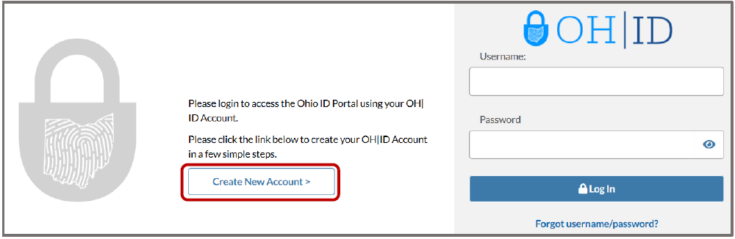

- Enter your information into the form (Name, etc.). Once you read and agree to the disclaimer, click “I Agree” and then click “Next”.
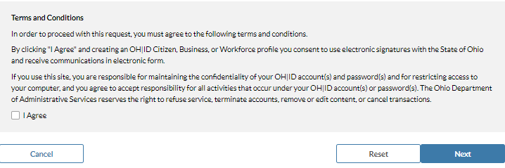

- On the next screen you will create your username and password. Save this information in a

secure place, as you will use it to login to DODD applications. This is your OH|ID login information.

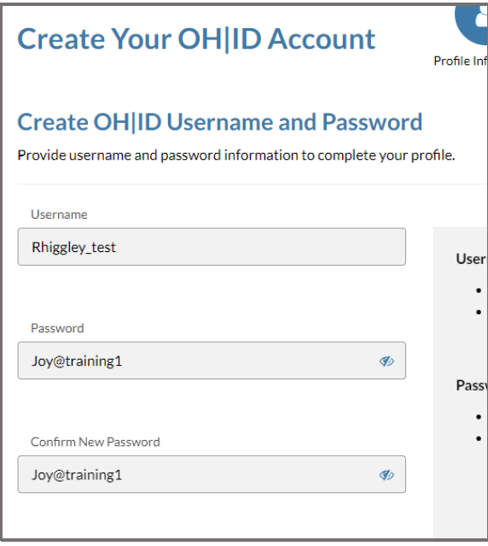

- Scroll down the page and locate a section titled Choose Password Recovery Methods. These password recovery methods help you reset your password in case you forget it. You must configure at least one recovery option, but DODD recommends that you configure all three. Once you have configured your recovery methods, the “Create Account” button will become active. Click the button.

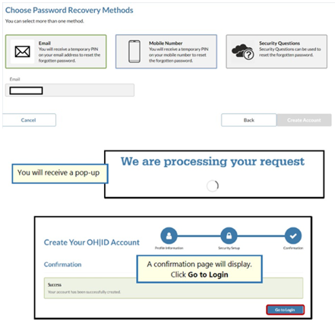

- You will receive an email like the one below. The email will list your Name and your OH|ID
username. You can save this email for future reference.
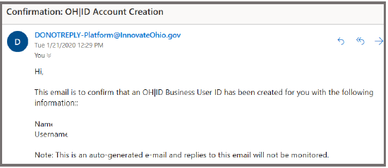

That’s it! You now have an OH|ID username and password. You may now request access to DODD applications.

Requesting Access to DODD Applications

- Navigate to the DODD homepage (http://dodd.ohio.gov) and click the Login button (highlighted below) in the right-hand corner.

- You will be redirected to OH|ID login screen. Enter your OH|ID username and password for authentication.
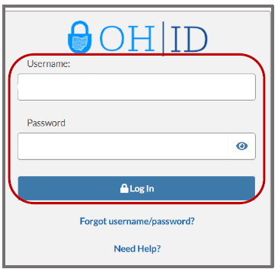

To request access to the GMS DODD application, click on the My DODD Application tile (See below).

If you have not accessed the DODD application tile before, locate the Available Apps section

and add it. This section houses tiles for applications that you have access to but have not yet configured.

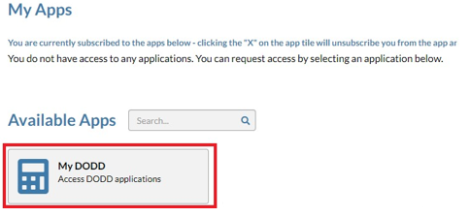

- After you click on the My DODD tile, the terms and conditions for the application will pop up. Once you have scrolled to the bottom of the pop up, click the box next to “I Agree.” After accepting the terms and conditions, click the “Request Access” button to request access to the application.

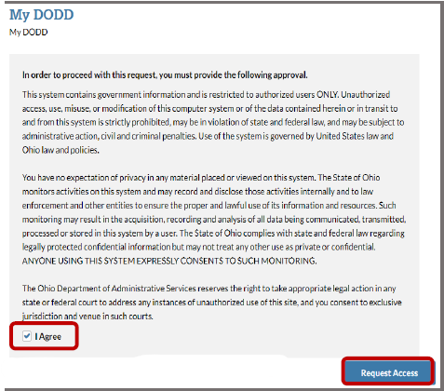

- After submitting your access request, you will receive a confirmation email that your access request has been received and needs to be approved by the administrator. Once approved, click the “Return to Applications” button to access the Applications menu.
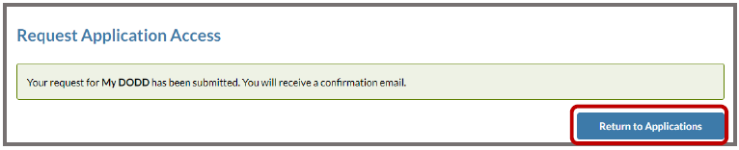

- You will receive an email when your account is ready. This may take a day or two. Once the email arrives, log back into the DODD portal using steps 1 & 2 above. (See below)
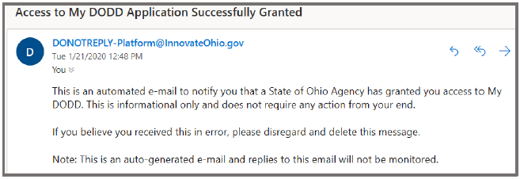

If you are presented with the below screen, a tile will be listed under the My Apps section. If the tile is not available under your My Apps section and you have already received the above email, contact the DODD ITS Call Center by calling 800-617-6733 Option 4.

GMS ROLES: PREPARER & SUBMITTER
- Open https://dodd.ohio.gov/

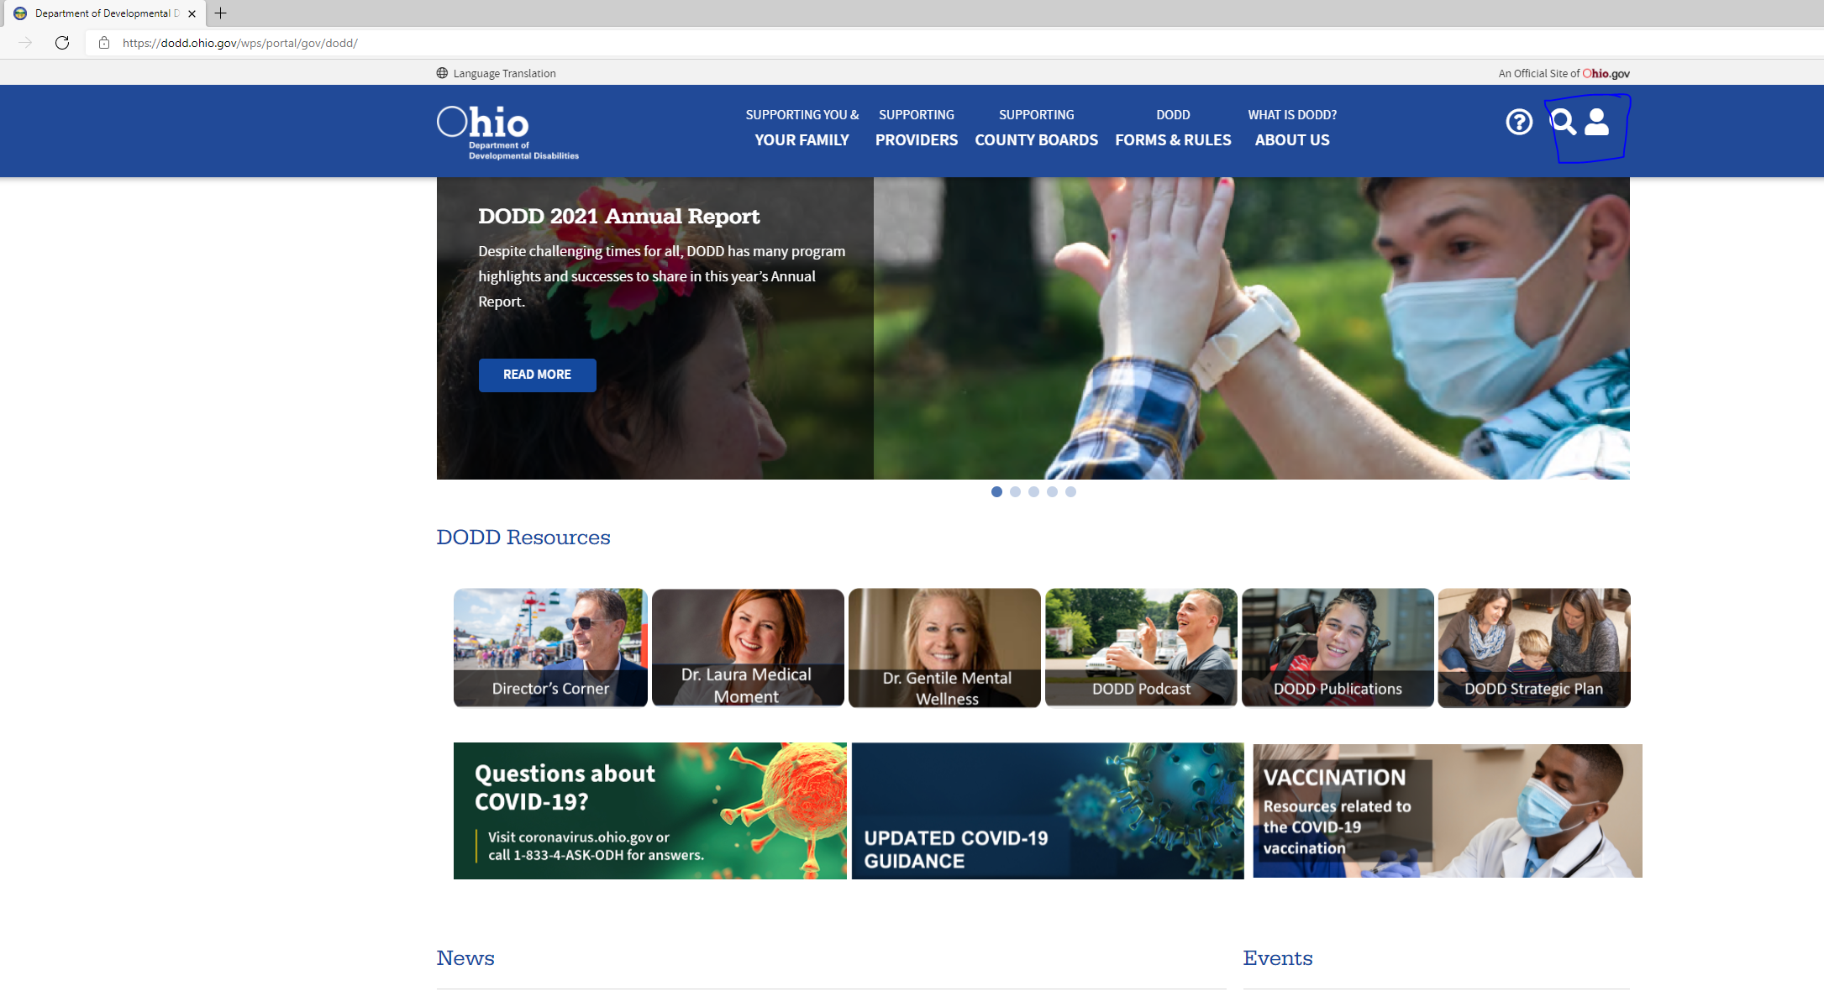

- Click on the User icon located at top right on the DODD site home page and you will be redirected to https://ohid.ohio.gov.
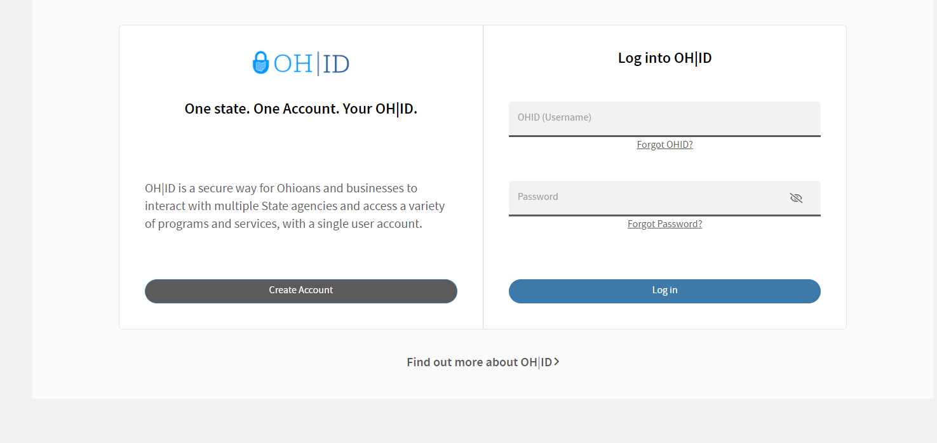

- Enter your OHID and password and click on Log in button. Please wait for few seconds and you can see DODD identifier page like below.
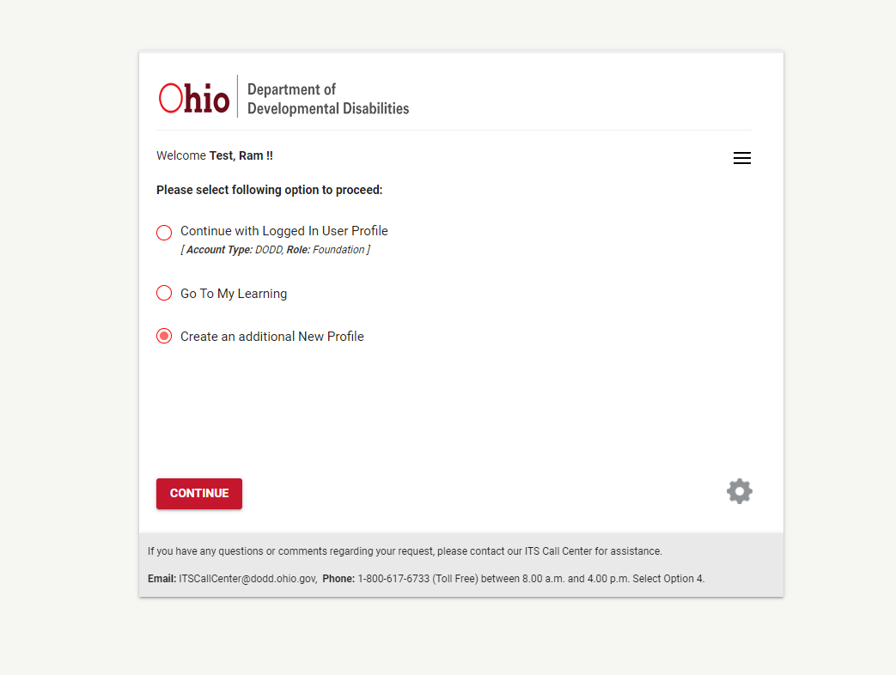

- Select ‘Create an additional New Profile’ option and hit Continue.
A new screen pops up where you need to select GMS application. Select the option ‘I need access to the Grant Management System (GMS)’ and hit Continue.
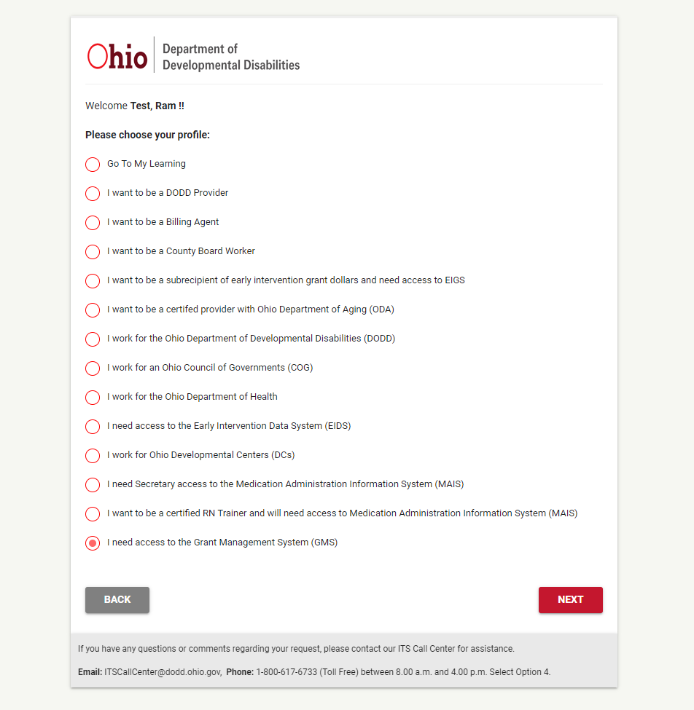

- To request Preparer/Submitter roles, you must select YES to the question ‘Do you have Supplier ID’ on this screen and Click NEXT button.
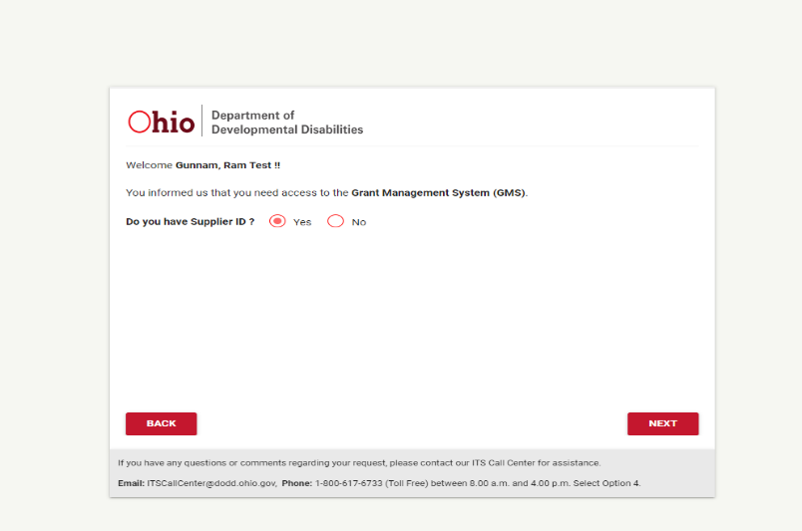

- Enter your 10-digit Supplier Id in the text box and hit Search. You will see the list of search results with Name and Address information.
Note: Supplier ID is a 10-digit number (Per OAKS system). Please prefix 00000 before numbers. For example, supplier ID for ADAMS county is 56160 but I have entered 0000056160 in the search box.
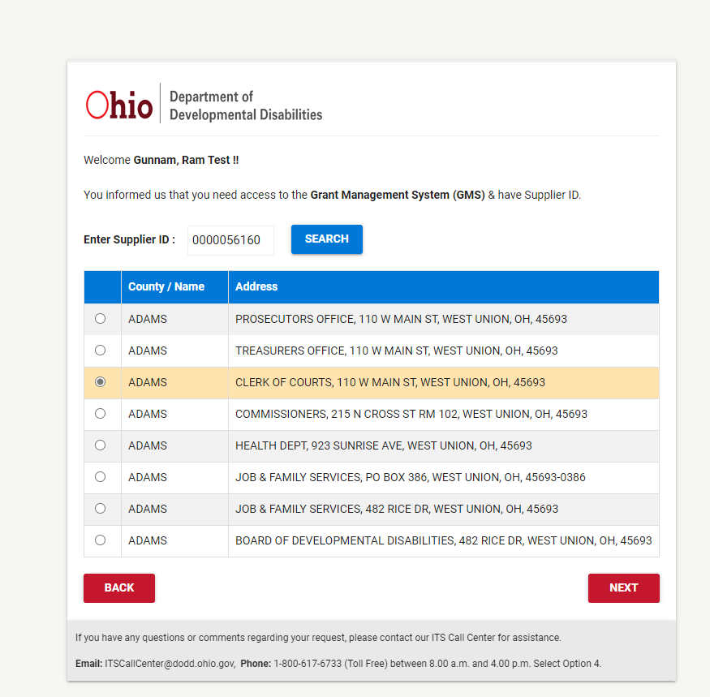

- Select the Organization/County with address info you want and click NEXT.
- After you click NEXT, you will a screen to select your role. Select Preparer/Submitter and click Continue.
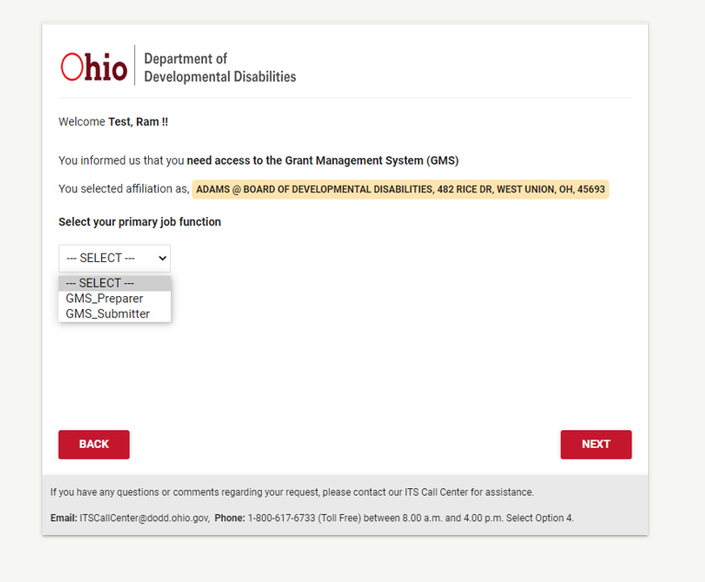

- Enter the PIN you have created while setting up your DODD account and click on Submit.
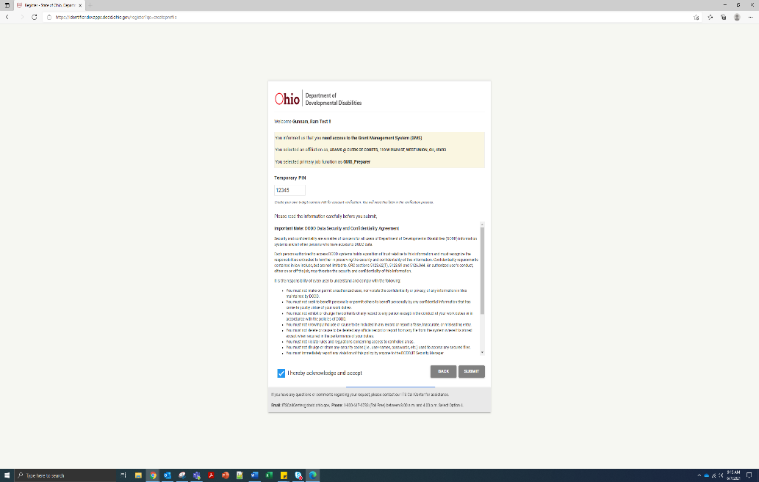

You will see a confirmation screen like below.
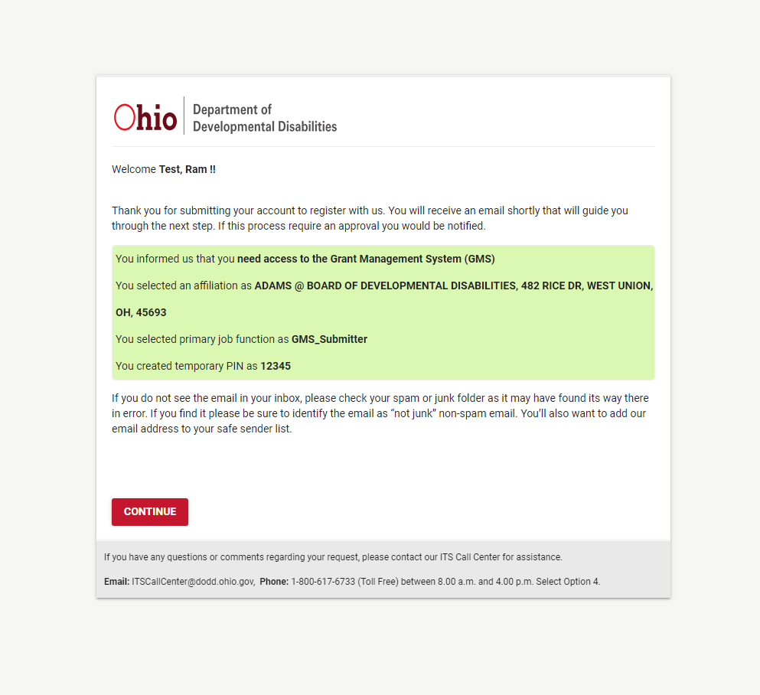

- Click on Continue. You will be navigated back to home screen.
- Keep an eye on your mailbox. You will receive an email from DODD to confirm your new profile request.

Email from DODD
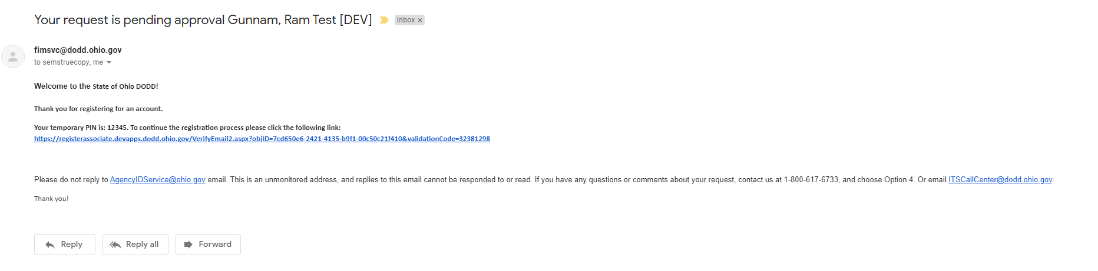

- Click on the hyperlink in the email body to confirm your email address. Enter the PIN and click Continue. A confirmation screen will show up that email verification is completed.
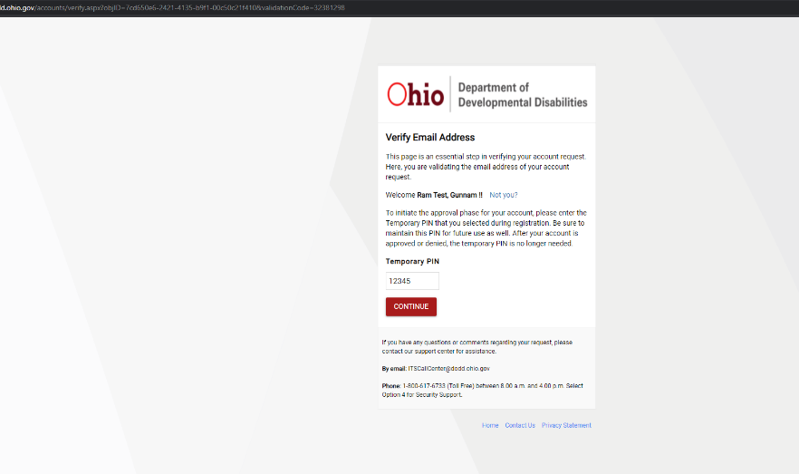

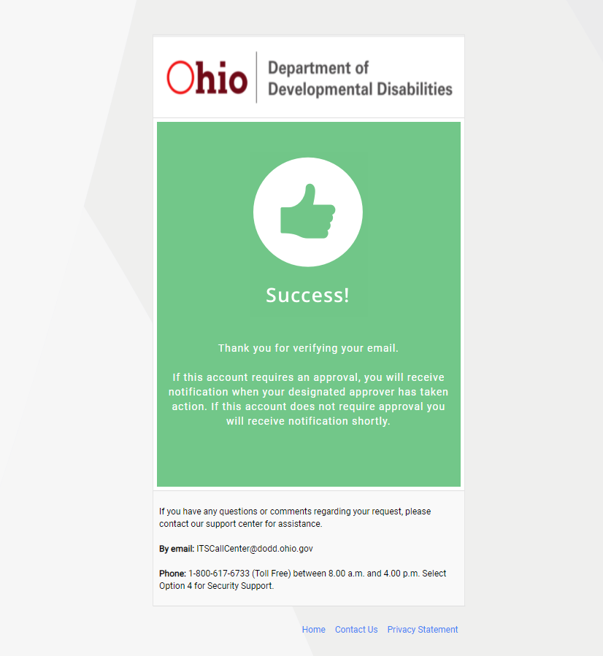

- Now, you will receive another email from DODD saying your request for GMS profile has been approved.
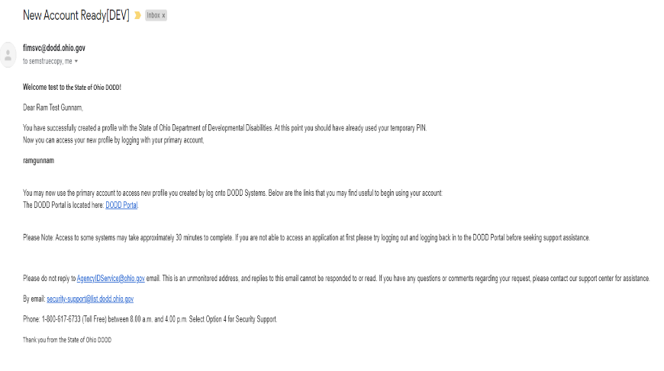

- You are all set to use your new role and navigate to salesforce.
Login back DODD using https://dodd.ohio.gov and click on User icon and enter your OHID and password.
You will be landed on identifier apps page.

- Select the profile you have created from the list of profile options and click Continue.
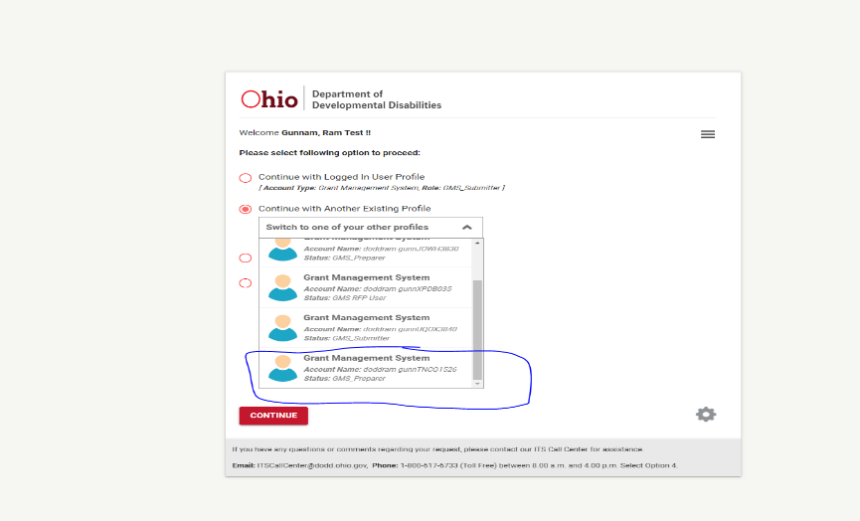

- You can see DODD application portal. Click on the Applications tab to see the GMS application tile.
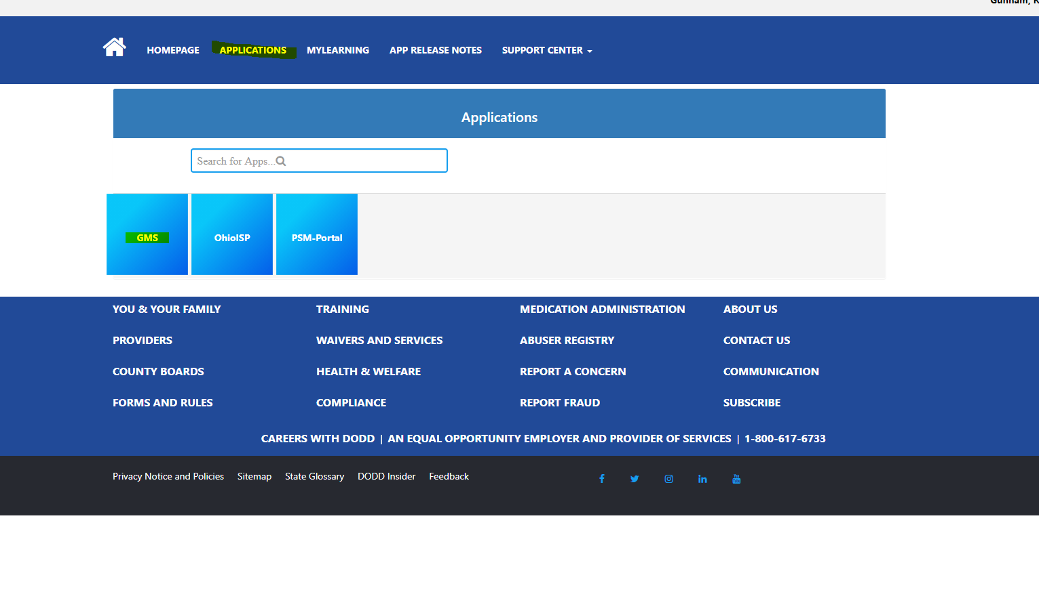
- Click the tile “GMS” to activate it.
  - Once you click on the GMS application tile, you will be navigated to GMS community page
    - Click on DODD-GMS Community Login button to login into GMS community with your OHID credentials.

