Exhibit E - EIGS Application Access for New & Existing Users

All application users will need to have an OH|ID account through the DODD Portal in order to request access to any of DODD’s Applications.

Note: If you already have an OH|ID username, please skip to page 3 “Requesting Access to DODD Applications”. For any registration or login issues, please call the DODD ITS Call Center at 800-617-6733, Option 4.

Creating an OH|ID account through the DODD Portal

- Navigate to the DODD homepage (http://dodd.ohio.gov) and click the “Login” button (highlighted below) in the right hand corner.

- On the page below, click the “Create New Account” button.
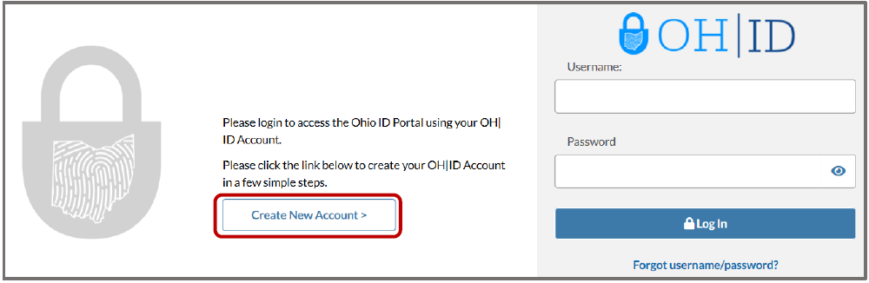

- Enter your information into the form (Name, etc.). Once you read and agree to the disclaimer, click “I Agree” and then click “Next”.
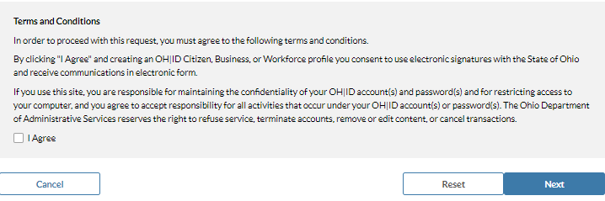

- On the next screen you will create your username and password. Save this information in a secure place, as you will use it to login to DODD applications. This is your OH|ID login information.

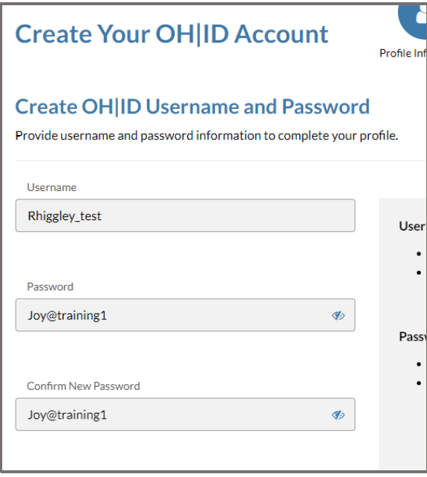

- Scroll down the page and locate a section titled Choose Password Recovery Methods. These password recovery methods help you reset your password in case you forget it. You must configure at least one recovery option, but DODD recommends that you configure all three. Once you have configured your recovery methods, the “Create Account” button will become active. Click the button.

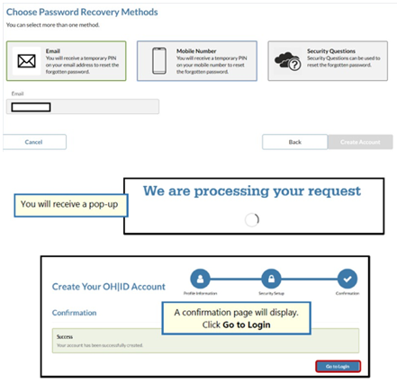

- You will receive an email like the one below. The email will list your Name and your OH|ID
username. You can save this email for future reference.
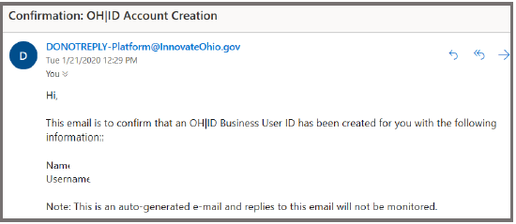
That’s it! You now have an OH|ID username and password. You may now request access to DODD applications.

Requesting Access to DODD Applications
Note: If you already have access to DODD applications such as EIGS, and have already established roles, please skip to page 12 “Accessing EIGS”.

- Navigate to the DODD homepage (http://dodd.ohio.gov) and click the Login button (highlighted below) in the right hand corner.

- You will be redirected to OH|ID login screen. Enter your OH|ID username and password for authentication.
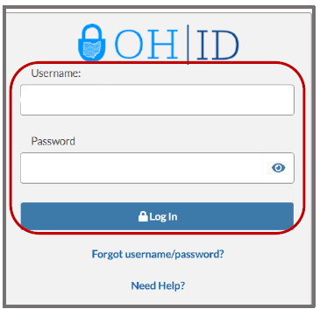

To request access to a specific DODD application, click on the My DODD Application tile (See below).

If you have not accessed the DODD application tile before, locate the Available Apps section and add it. This section houses tiles for applications that you have access to but have not yet configured.

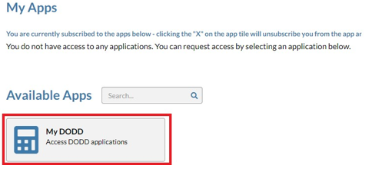

- After you click on the My DODD tile, the terms and conditions for the application will pop up. Once you have scrolled to the bottom of the pop up, click the box next to “I Agree.” After accepting the terms and conditions, click the “Request Access” button to request access to the application.

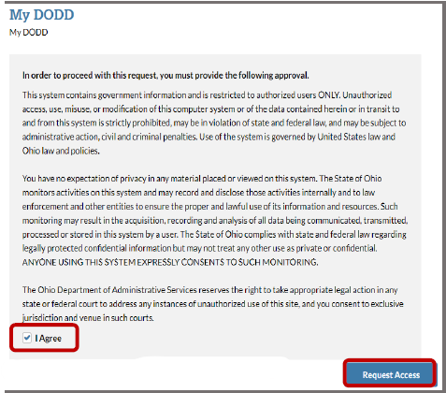

- After submitting your access request, you will receive a confirmation email that your access request has been received and needs to be approved by the administrator. Once approved, click the “Return to Applications” button to access the Applications menu.
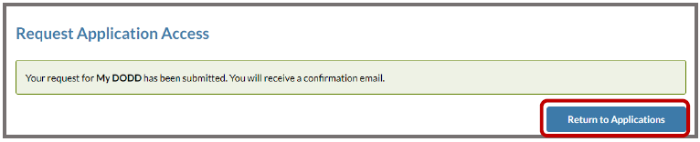

- You will receive an email when your account is ready. This may take a day or two. Once the email arrives, log back into the DODD portal using steps 1 & 2 above. (See below)
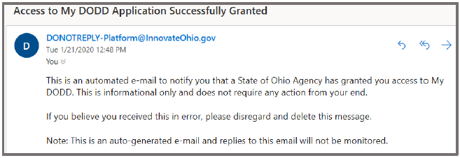

If you are presented with the below screen, a tile will be listed under the My Apps section. If the tile is not available under your My Apps section and you have already received the above email, contact the DODD ITS Call Center by calling 800-617-6733 Option 4.

If you have previously established roles within the DODD portal you will see the identifier page below.
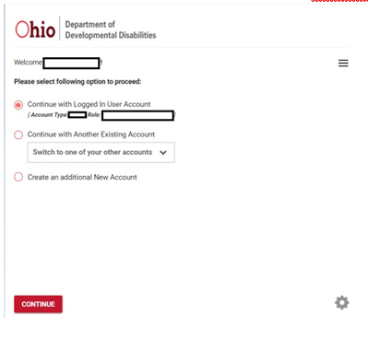
If the screen you see is the screenshot below, user roles will need to be established prior to application use.
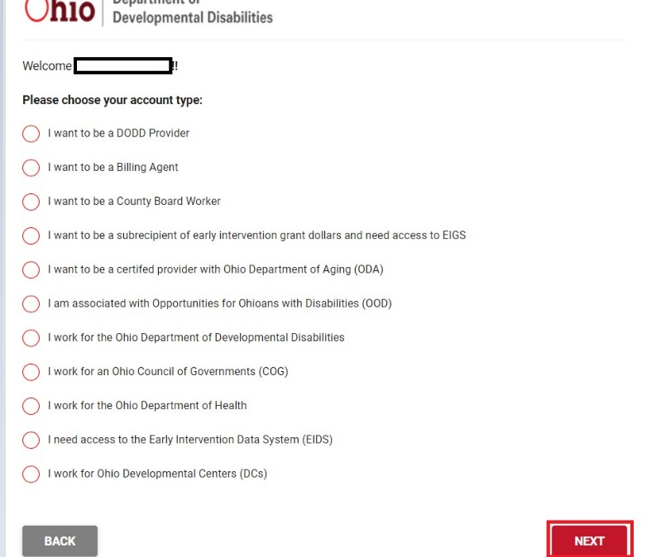

Configuring/ Establishing User Roles
- To establish user roles prior to application use, select your account type and click “Next”.

- Choose your profile and then click “Next”. Individuals that are employed by a county board of developmental disabilities would select “I want to be a County Board Worker” if this is the first time, they are attempting to access DODD applications. Individuals who don’t work for county boards of DD will select “I want to be a subrecipient of early intervention grant dollars and need access to EIGS”.
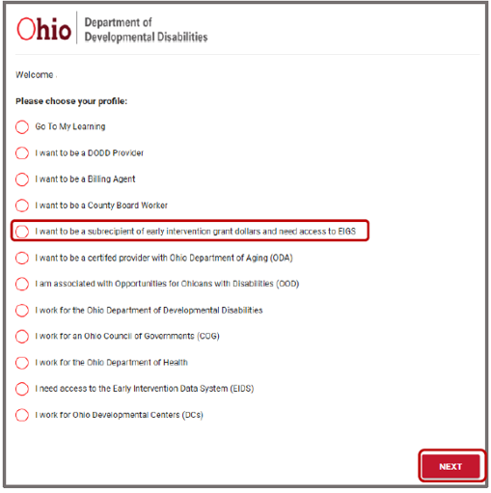

- Users: Select the correct county and then select the correct Primary Job function from the drop-down box as shown below.

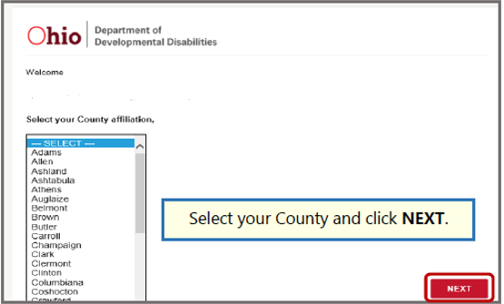

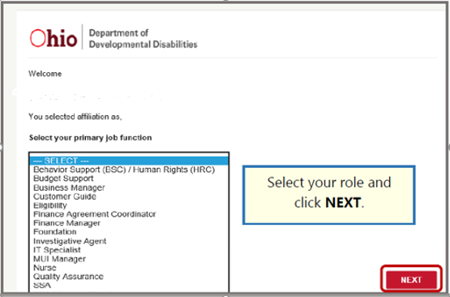

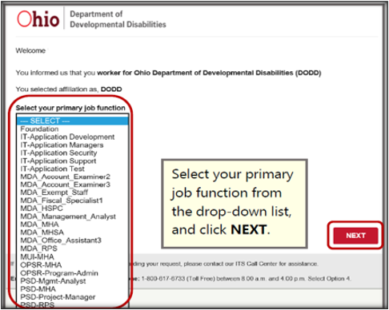
- Once you have selected your options, you will see the below screen that will prompt you to create a Temporary PIN. The PIN is not your password and is only used once. Enter a Temporary PIN, click the acknowledge and accept checkbox and then click Submit.

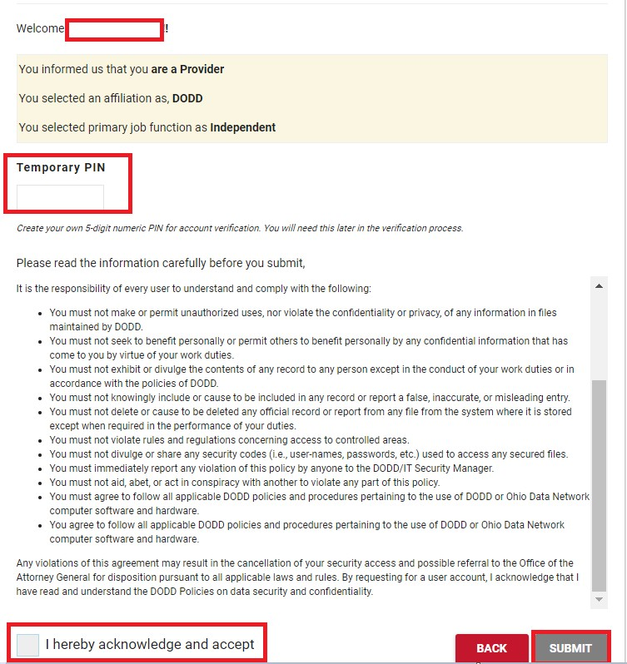

- Once you click Submit, a confirmation page is displayed.
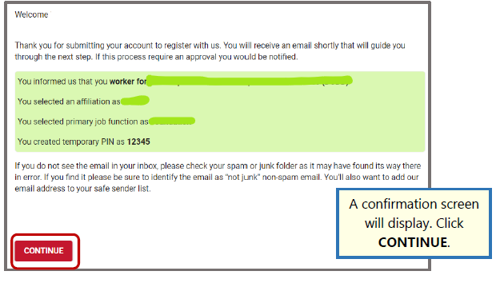
Note: Users may require review by an Approver for additional roles. If so, below is the screen that will display.

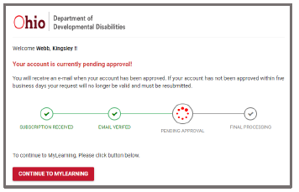

- For DODD users: You will receive an email like the one below. Click the link in that email and enter in the Temporary PIN that you created in the previous step. Click Continue.

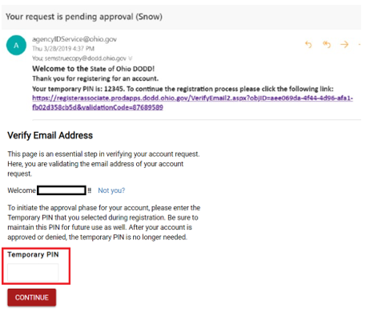

- Once you enter your Temporary PIN which thereby verifies your email address, you will see a green thumbs up page. NOTE: It can take up to 30 minutes before your applications become available. Additionally, some role requests have to be approved. You will receive an additional email when your account is approved.

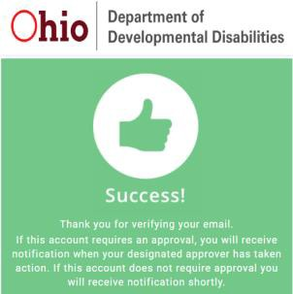
That’s it! You have now created a DODD account to be used to login to DODD applications.

Accessing EIGS
- Log into the DODD Portal by entering your username and password.
- Click continue

- Click “Applications” at the top of the page
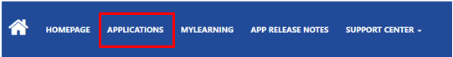

- Click the “EIGS” tile
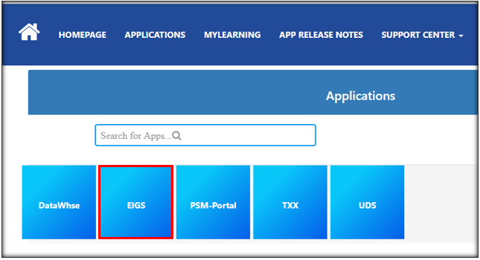
You did it! You should now be able to view your roles associated dashboard.

