The PSP Approach to Teaming and the
Service Coordinator’s Role:
Helpful Strategies for Service Coordinators

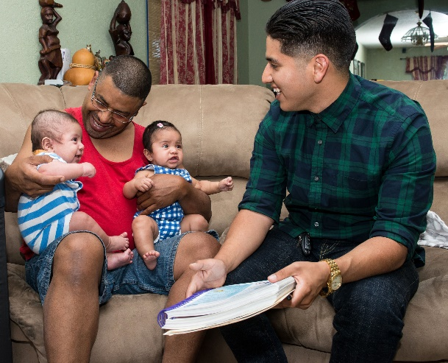
Coaching
Set reasonable expectations about coaching. It takes practice, and every situation is different.
If he/she is willing to learn, coach the PSP about resources so they can walk families through the process of accessing supports and services outside of EI (e.g. BCMH, Medicaid, etc).
Coach is not an authoritative role but
a supportive role.

Teaming
Use the Team Meeting Agenda from the Shelden and Rush Teaming Handbook.
Use team meetings to ensure everyone is on the same page and there is no miscommunication.
Be positive and strengths-based when introducing the family to the team.
Understand the importance of Service Coordination! It takes time to build your skills and determine how you fit on the team.

Monitoring Service Delivery
Stay organized.
Meet with families at least once a month with PSP.
Make periodic phone calls to check in with families.
Use quarterly reviews to check on the progress of outcomes.

General
Become familiar with local resources. One source of information is the electronic resource directory maintained by Central Coordination.

Observe other Service Coordinators and incorporate positive elements you observe into your own practice. Learn from other team members.

Take your time and try not to feel rushed. Think quality vs. quantity.

Have a plan, but be open to changing the plan when needed.

Resources
Shelden, M. L., & Rush, D. D. (2013). The early intervention teaming handbook: The primary service provider approach. Baltimore: Brookes Publishing
Team Agenda: http://archive.brookespublishing.com/documents/Shelden-early-childhood-teaming-handbook-forms.pdf
Worksheet for Selecting the Most Likely PSP: http://fipp.org/static/media/uploads/casetools/casetool_vol6_no3.pdf

